UI/UX and Usability Study

**Introduction:**

The system under study is an application designed to allow current and past Massachusetts state employees to calculate the money in their month pension check. The user, current or past state employee, can add state jobs based on the years they worked and the compensation they made. Once they add state jobs, the user can calculate their pension by adding their date of birth, expected date of retirement, group number, and whether they are a veteran. Additionally, the user can choose between three different options to view how their pension will be received. They can also plan how long their pension will last them by entering a monthly spending budget. The following study tested some of the listed functionality.

This study was conducted with three random volunteers selected by convenience sample. The study was conducted with paper prototypes of what regular user, current or past Massachusetts state employee, would see when they login. Each participant was explained the purpose of the study and given a short explanation of the overall application. They were then asked to carry out three system tasks. The tasks were described briefly but the users were not given step by step instructions on how to carry out the tasks. Each task they performed was timed in order to indicate how long the particular task would take for a user. Additionally, they were asked to provide overall feedback on each task. They were asked a few follow-up questions regarding their demographics and satisfaction with the tasks. Overall, the goal of the study was to gain insight on the best way to design a pension calculator for the Massachusetts State Retirement Board.

**Paper Prototypes:**

**Task 1 –**

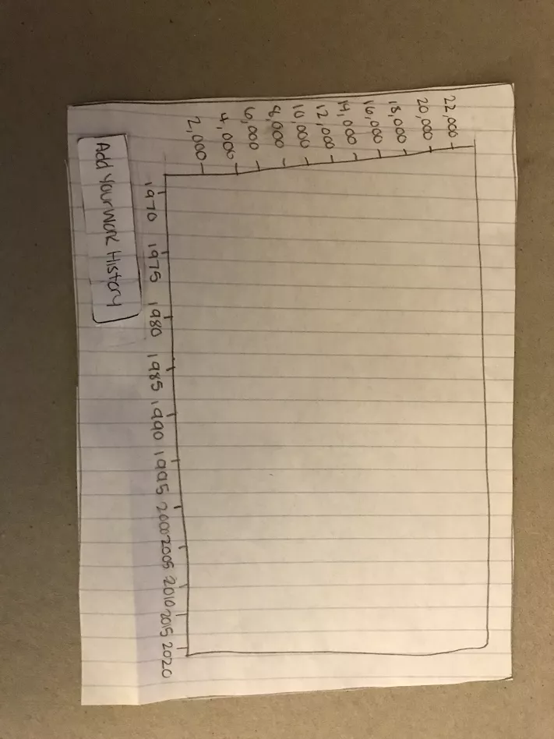

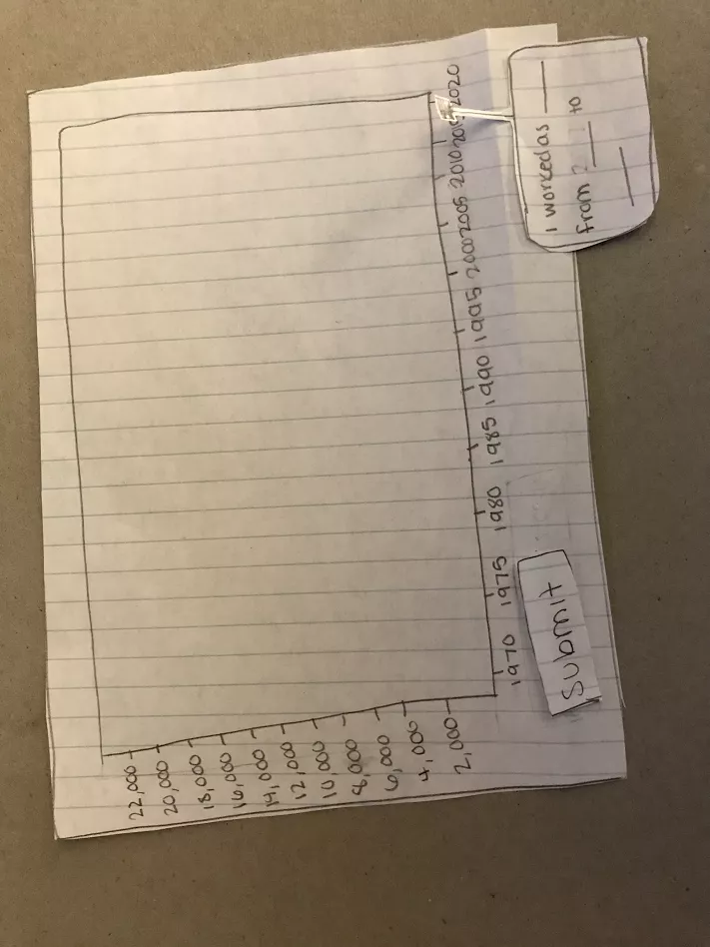

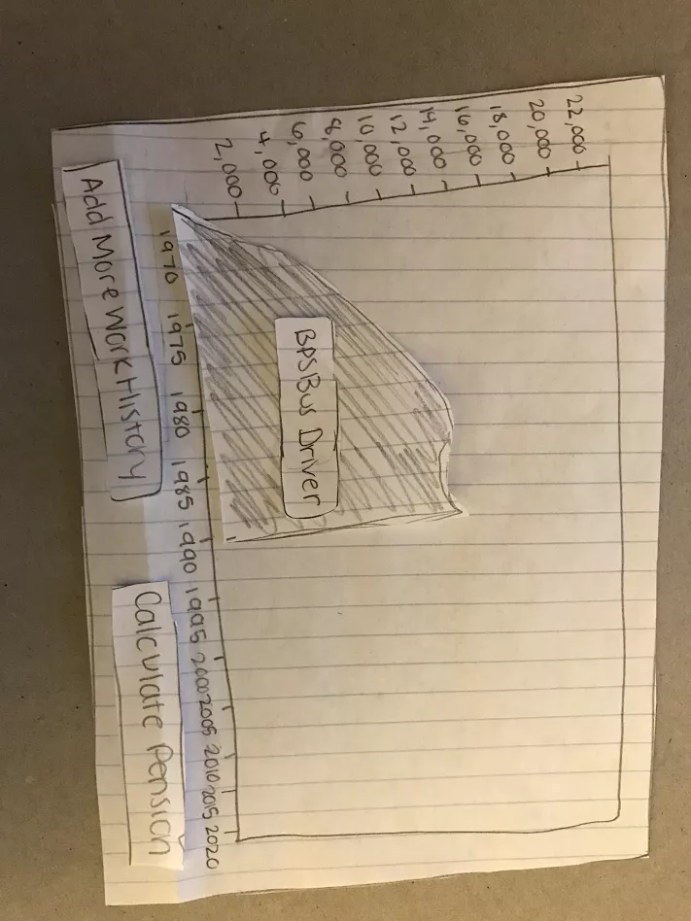

**Task 2 –**



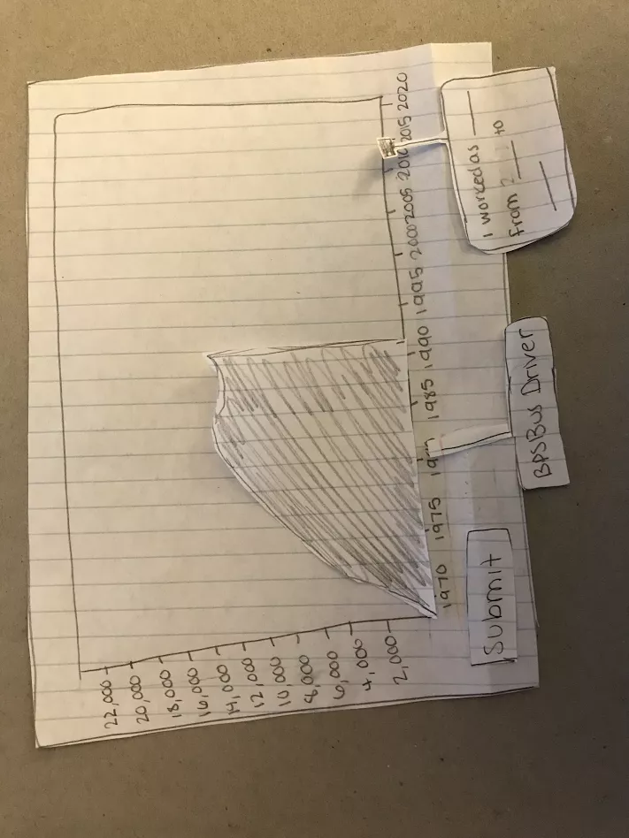

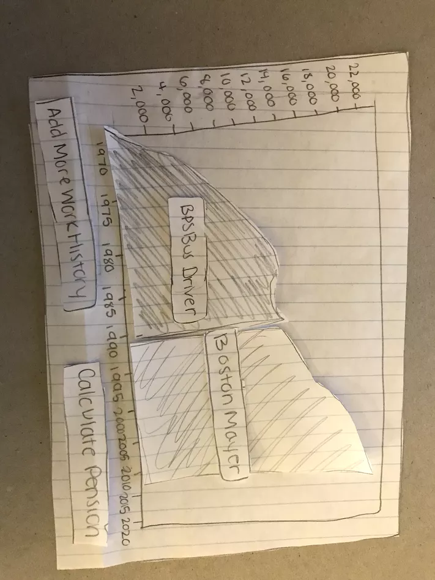

**Task 3 –**



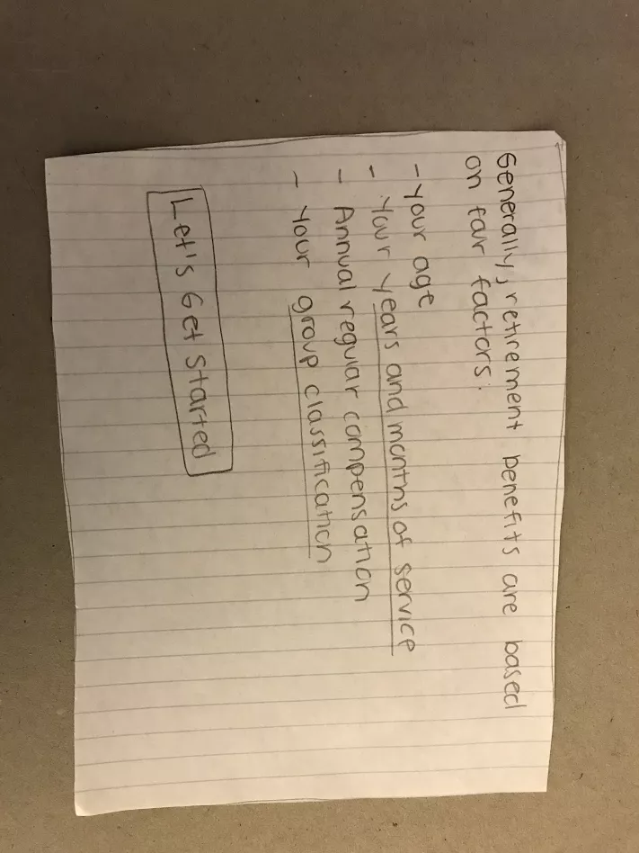

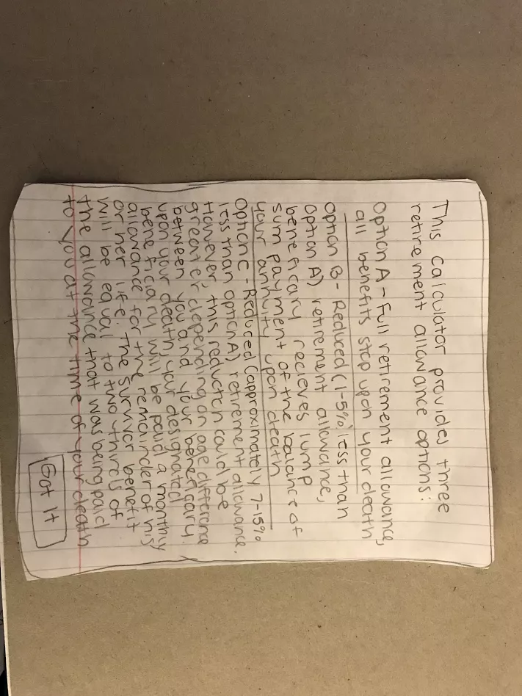

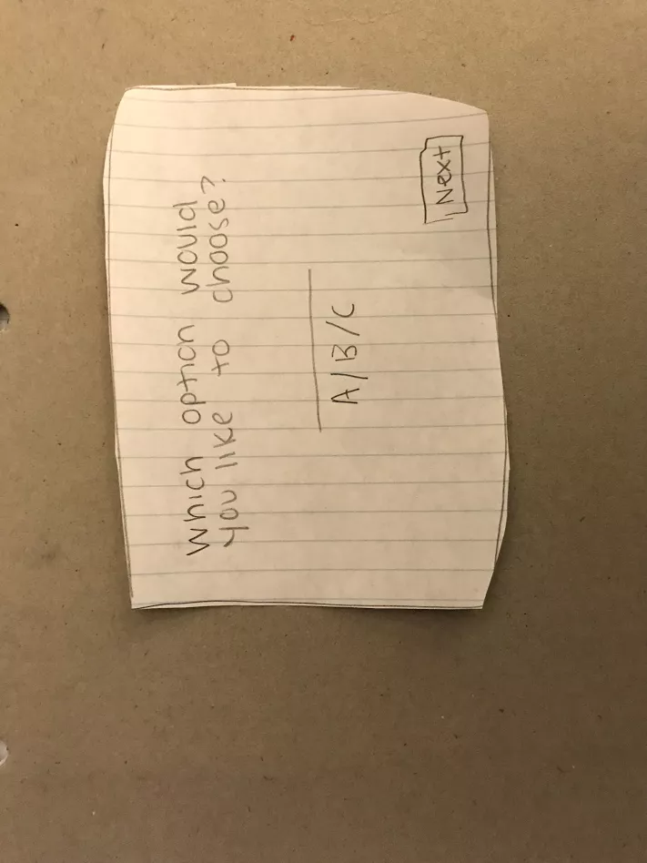

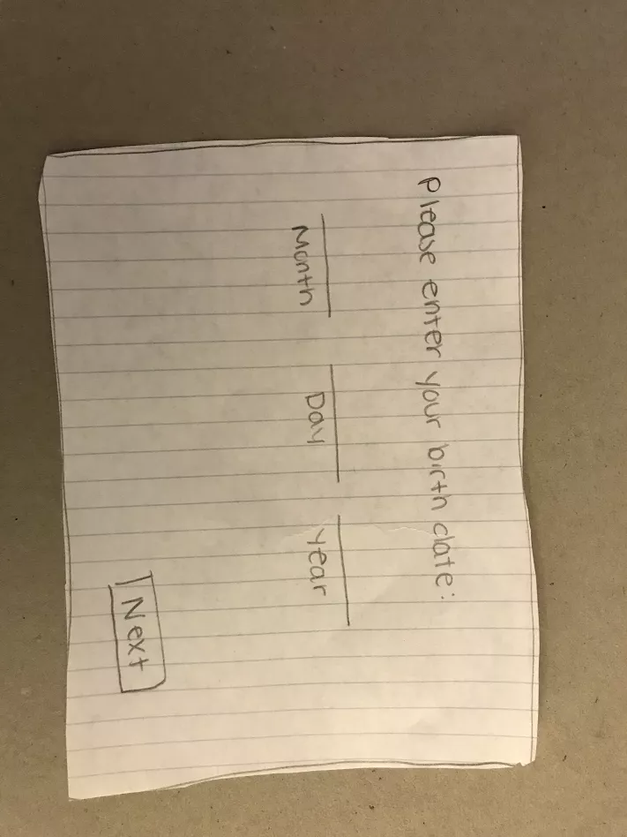

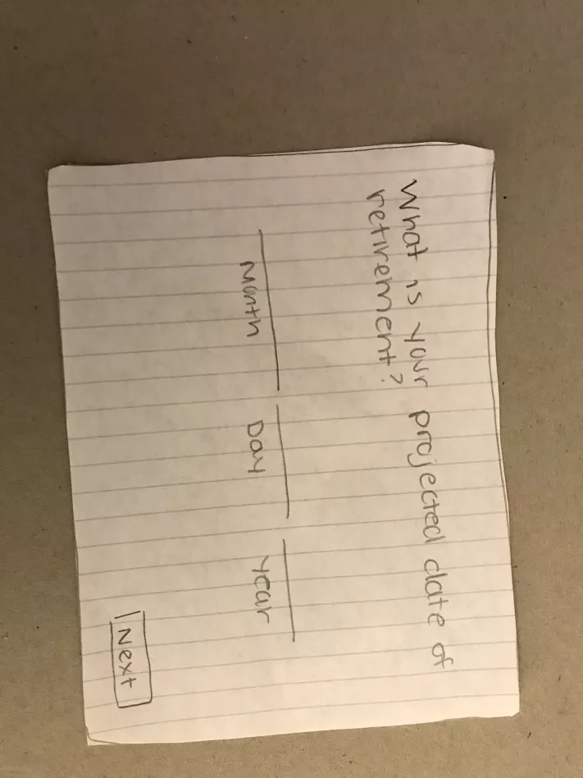

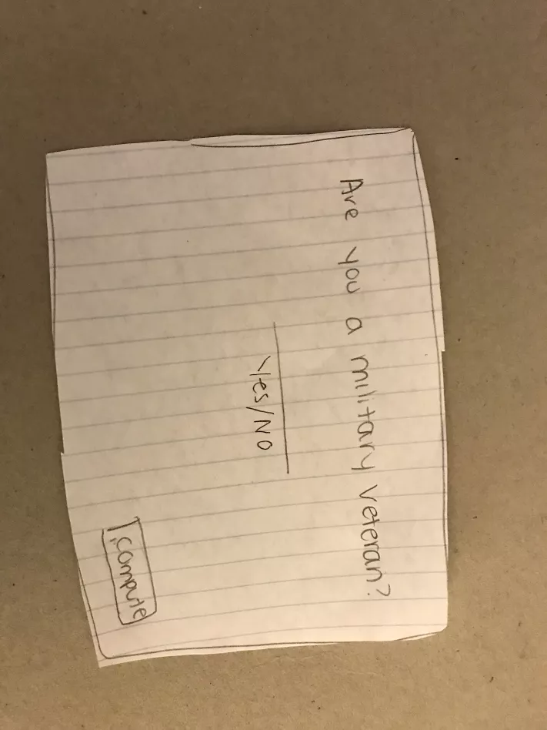

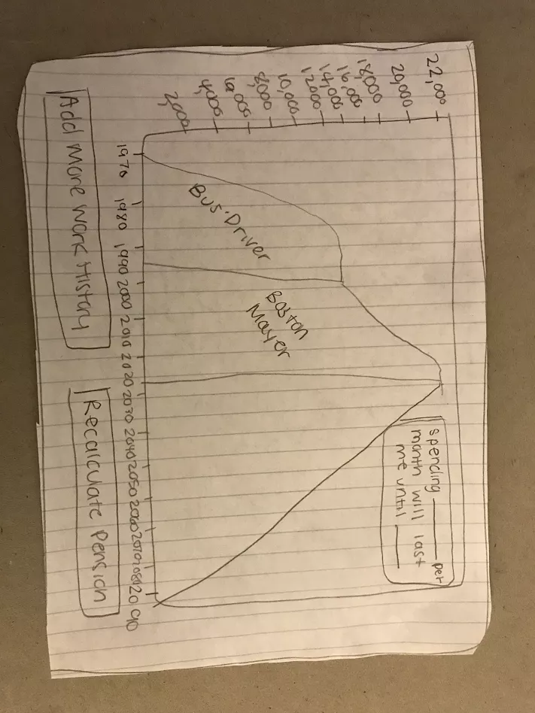

**Participant Demographics:**

* Age is a ratio measure. The standard deviation is 0.58 and the mean is 19.67. Two of the participants are 20 and the other is 19.
* 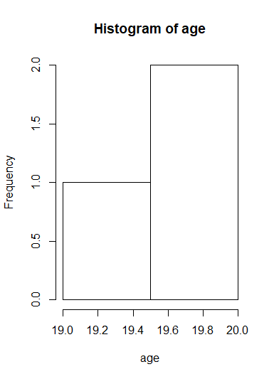
* Gender is a nominal measure. The mode for gender is male (66.67% of the participants are male). Two of the participants are male and the other is female.
* Education level is a ratio measure. It is measured as year in college. The standard deviation is 0.58 and the mean is 2.67. Two of the participants were in their third year and the other was in their second.

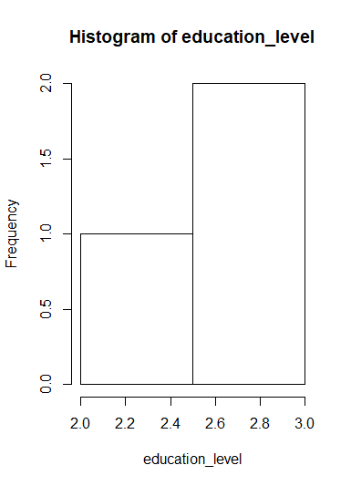

* Major is a nominal measure. There is no mode as all participants are different majors. One participant is a computer science major. The other is a finance major. The final participant is a nursing major.
* Years computer experience is a ratio measure. The standard deviation is 1.15 and the mean is 10.67. One participant has 12 years of experience. The other participants have 10 years of experience.

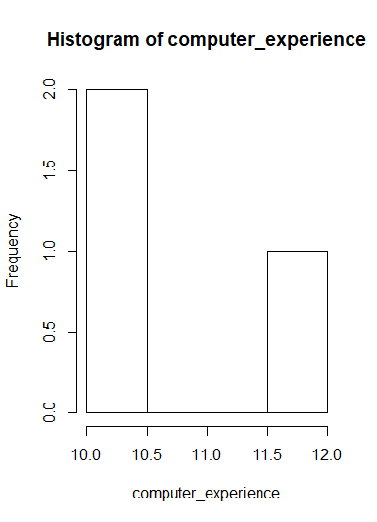

**Tasks:**

* **Add your Work History:**

Participants were asked to “Add your Work History”. The participant was presented with the generic login page where no jobs are currently added. They had to press the “Add your Work History” button. They were then brought to the page where they had to fill in their job title and the dates in which they worked at said job. They were asked to write in information with a pencil to serve as their cursor. Once they filled out they form, they had to press submit. For the sake of this study, they were asked to be a bus drive from 1969 to 1992.

* **Add More Work History**

Participants were asked to “Add More Work History”. The participant had to press the “Add More Work History Button”. They were then navigated to the form where they filled out their additional work title and state/end dates. For the sake of this study, they were asked to be the Boston Mayor from 1993 to 2017. Once they filled out the data, they had to press submit.

* **Calculate Pension**

Participants were asked to “Calculate Pension”. They had to select the “Calculate Pension” button. They were then navigated to an instruction page where they had to select “Let’s Get Started”. They were then given instruction on the different options they could choose from. Once they read through the options, they had to select “Got It”. Then, they were asked to choose one of the options they were briefed on and click “Next”. They next view pages asked for date of birth, date of retirement, and whether they were a military veteran. Once they filled out this information, they had to select “Calculate”. Finally, they were navigated to the page that displayed their pension. For the sake of this study, they were asked to select “Option A” and 2020 as their date of retirement.

**Measurements:**

Each task was measured in seconds for how long it took the individual. As each participant started each task, the start button on the timer was pressed. The timer was stopped once they had completed the task. Below are the results from timing each task:

|  |  |  |  |
| --- | --- | --- | --- |
|  | Task 1 (seconds) | Task 2 (seconds) | Task 3 (seconds) |
| Participant 1 | 41 | 34 | 76 |
| Participant 2 | 45 | 43 | 82 |
| Participant 3 | 39 | 37. | 93 |

For task 1, the mean time is 41.67 and the standard deviation is 3.06. For task 2, the mean is 38 and the standard deviation is 4.58. For task 3, the mean is 83.67 and the standard deviation is 8.62.

**Test Results:**

Task one produced some interesting results. When the participants were asked to “Add your Work History”, they could associate this functionality to the “Add your Work History” button. All the participants could find the button without commentary. Some participants had a tougher time with the form than others. For example, participant three said, “It’s confusing how the submit button is separate from the form”. Participant two wasn’t sure what to include in the to and from fields. More specifically, they weren’t sure if they should add month and day or just year as part of the date. All participants could recognize the completion of the task when the bus driver graph appeared on the screen. The completion of task one resulted in some valuable data.

Task two was the quickest task to complete for participants. Because the interface was very similar to the previous task, participants had no trouble selecting the “Add More Work History” button. They were then able to fill out the same form they filled out in the previous task with no commentary. Once they hit submit, the recognized the completion of the task as the Boston Mayor graph appearing on the screen. Overall, task two was the easiest to complete for all participants and there wasn’t much feedback.

Task three seemed to be the most confusing tasks for participants and contained the most hesitation when selecting options. Participants easily selected “Calculate Pension”. They were then navigated to the instruction screen. Participant two wished there was more information on what “group classification” meant or at least a clear way to navigate to a page with more information. They suggested a pop-up when you hovered over the word. Once the participants pressed “Let’s Get Started”, they were navigated to the option informational page. Once they read about the different options, they selected the “Got It” button. Participant one commented on how it was strange that the buttons were on opposite sides. They were then asked to select the option they wished to calculate. Participant two said they would hope the interface would have a drop down. Participant three mention that it would be nice to have a back button just in case someone wanted to reread the options. After they selected their option, they were asked to enter their date of birth, date of retirement, and whether they were a veteran. All participants had no trouble with these tasks. Once they hit the “Calculate” button, all the participants registered that the task was complete once the graph appeared. Participant one asked about the box up in the right-hand corner and mentioned that it was unclear what it’s functionality was. Overall, task three yielded some useful data.

**Discussion:**

If we wanted to truly capture the best design for this system, we would need to undergo this study with many more participants. The participant demographic is strictly limited to young college students based on the nature of the convenience sample. The measurements would be more accurate and meaningful if they were collected from a wider range of participants.

The data we collected did yield some useful results regarding what we should change about the current design. For entering work history, the pop-up box could be clearer. The to and from date fields could include drop-down calendars that the user selects to date from or a drop-down menu with just the year. Additionally, the submit button could be included on the pop-up box. We could add additional instruction to the calculate pension instruction page or we could add pop-up tips throughout the wizard form in order to remind users why they need to enter said information. Additionally, we could add back buttons so that the user could move back and forth between the questions. We should make sure that all buttons align and are in the same position among all the pages. Also, we should include drop-downs for all fields throughout the form. We could potentially use clickable calendars for the date fields. Although we did not test the planning functionality, we could add a label to the planning form so that it is clear what that pop-up box does. Overall, this study was extremely beneficial and we learned useful information about how to design our interface.